|  |  |
| --- | --- |
| **EX:NO**:09 | **SOFTWARE PERSONNEL MANAGEMENT SYSTEM** |

**SEQUENCE DIAGRAM:** 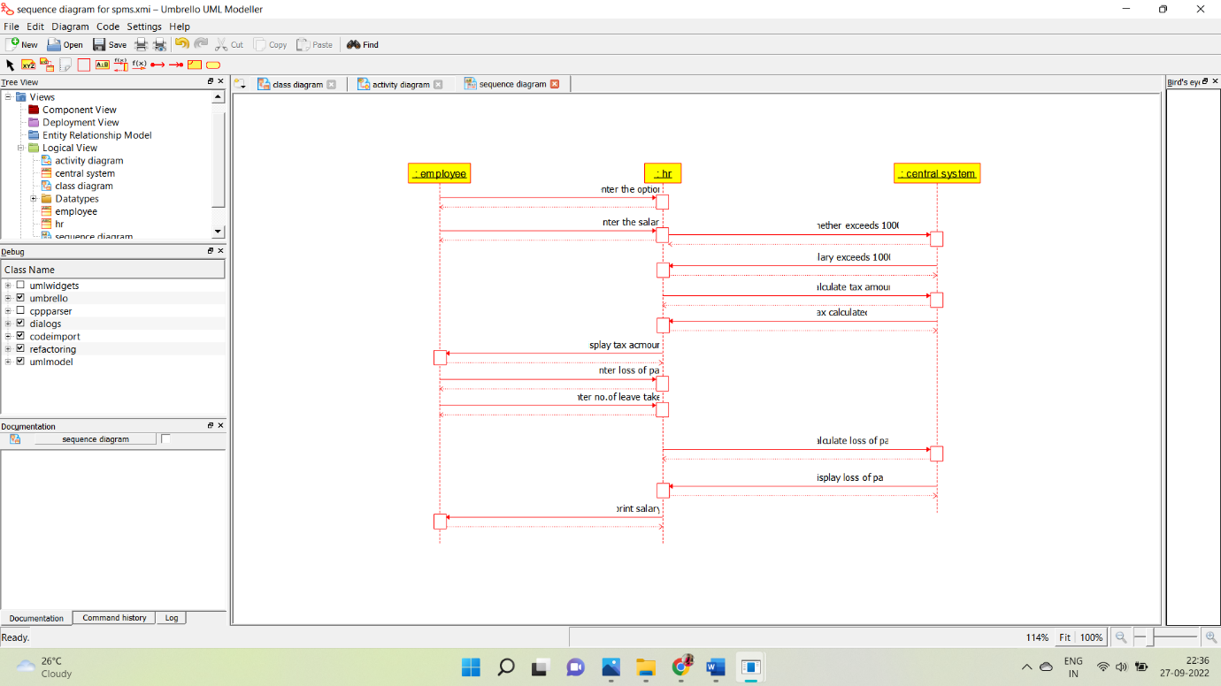

**COLLABORATION DIAGRAM:**

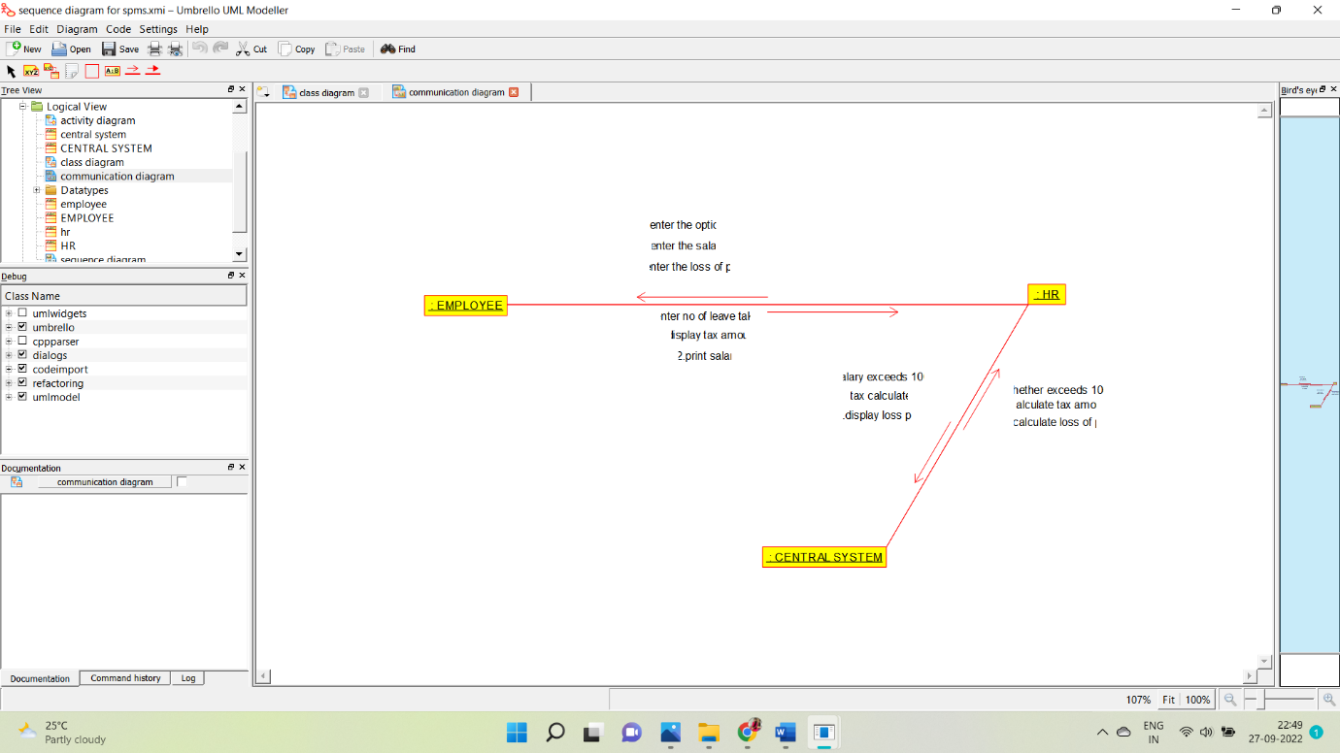

**COMPONENT DIAGRAM:**

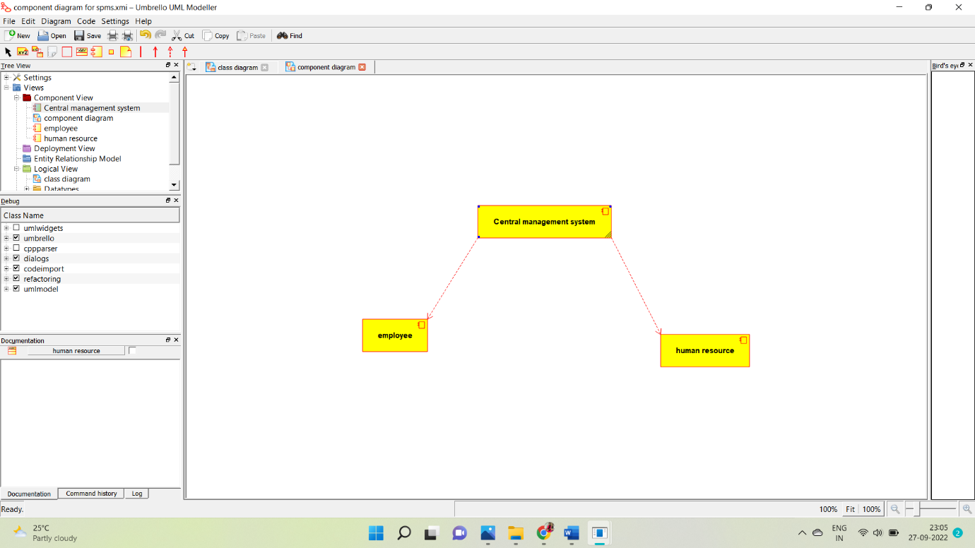

**DEPLOYMENT:**

